**Project 6 Coin Detection – Part 2 complete**

Name: ______Michael Fatemi_______ Period: ______7_____ Date: _____4/26/2021________

Did you name your file l062.cpp (Lower case L, then 062)? __Yes__

Did you create the edge matrix? _____Yes______

Did you create the gradient direction matrix? ­­­_____Yes______

Did you create the imagev.ppm (visual of votes)? _____Yes______

Did you use Bresenham's line algorithm for voting? _____Yes______

Does your application create coins.ppm file? _____Yes______

Does you code display on the screen and in results.txt a summary of your results? _____Yes______

Did you test your code on terminal/gnu linux in c++11? _____Yes______

Run your code (the same code you submit) on the 3 images I provided (easy, medium, hard) then paste here the following:

* The initial image ( the one I provided), the imagev.ppm, coins.ppm you obtained running your code, copy paste here the content of your results.txt file your code created

1. For the easy image:

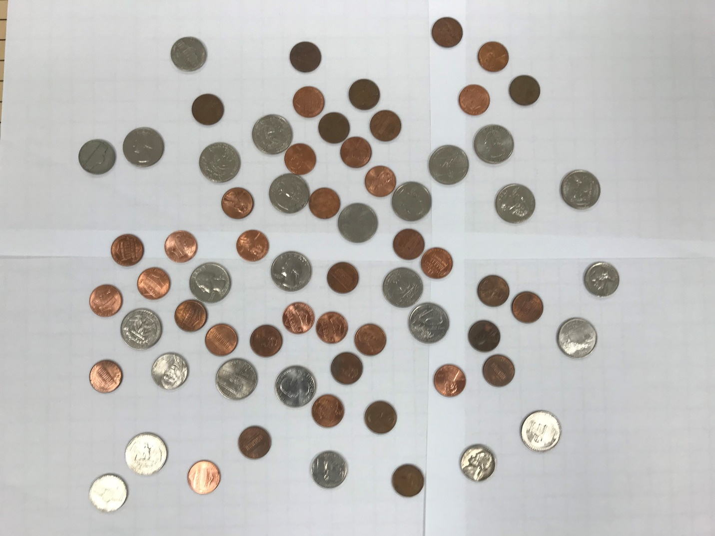

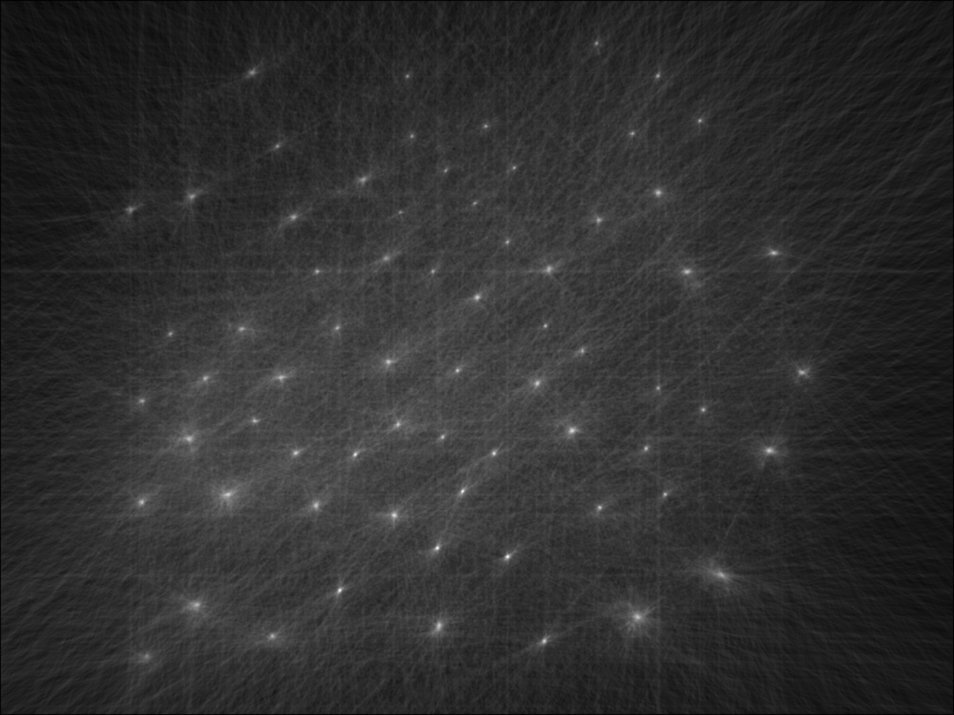

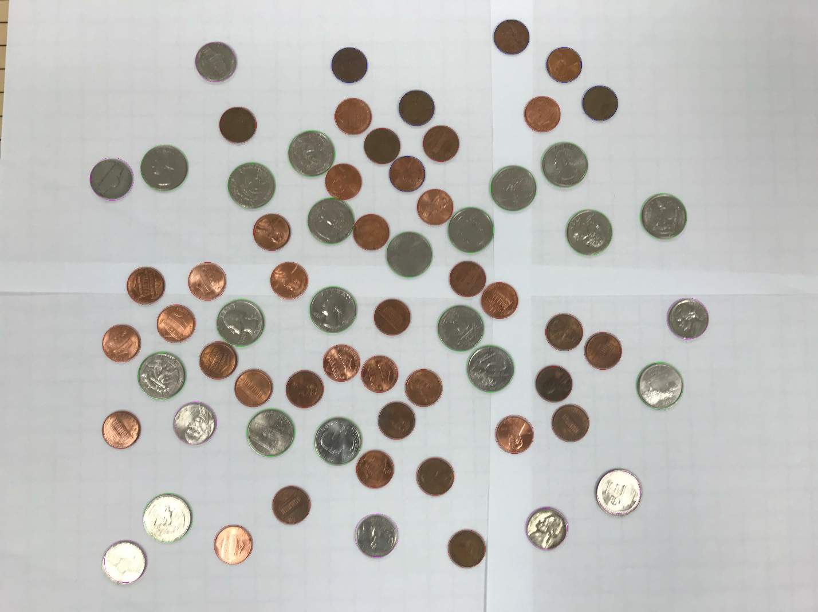

Results:

35 pennies

8 nickels

6 dimes

19 quarters

0 silver dollars

For a grand total of $6.10!

1. For the medium image:

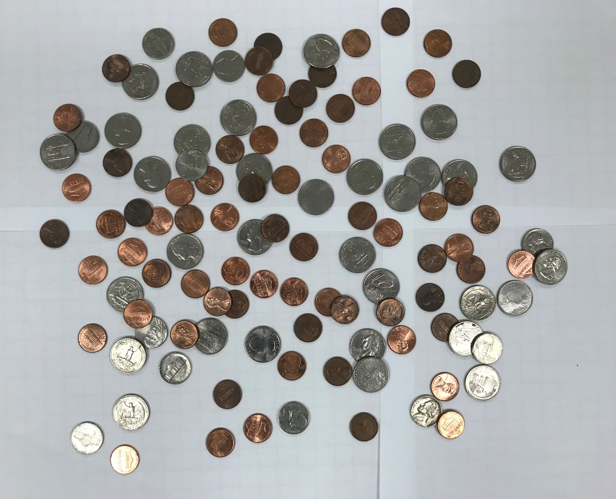

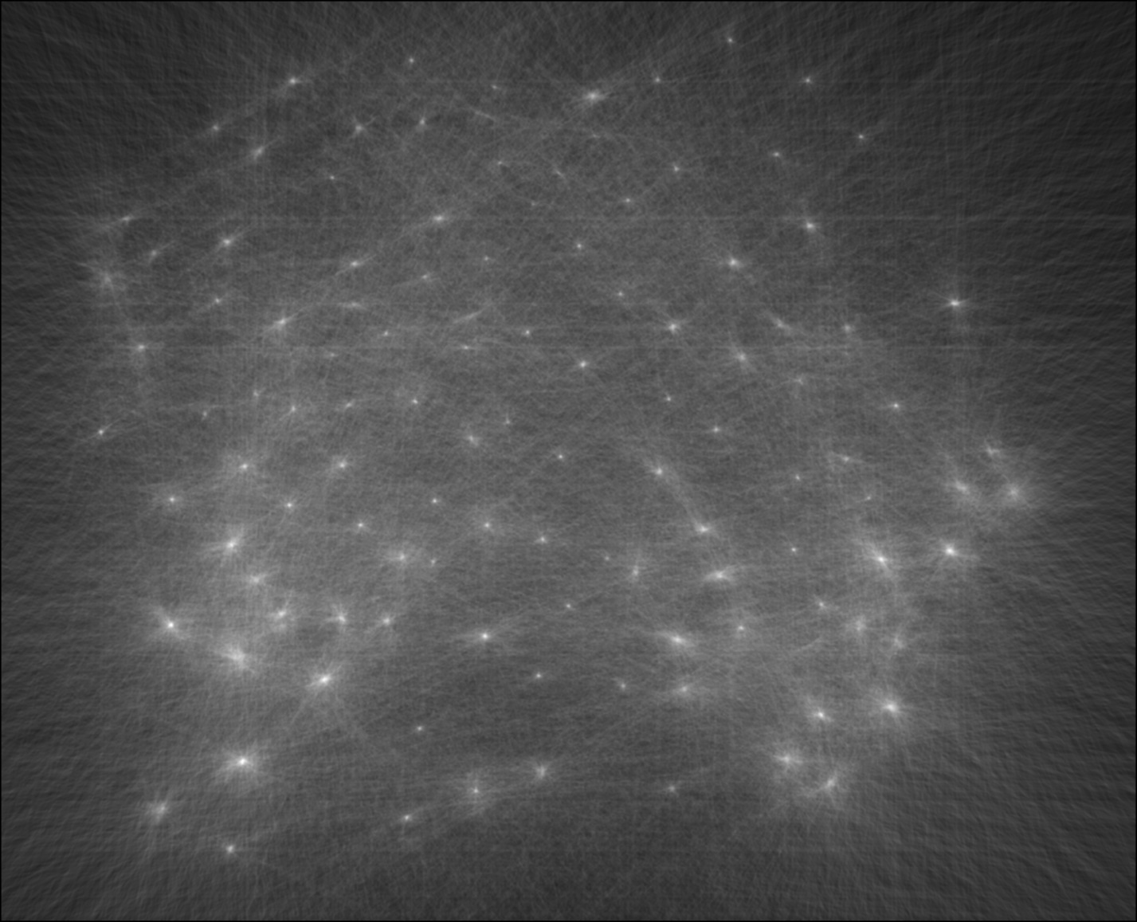

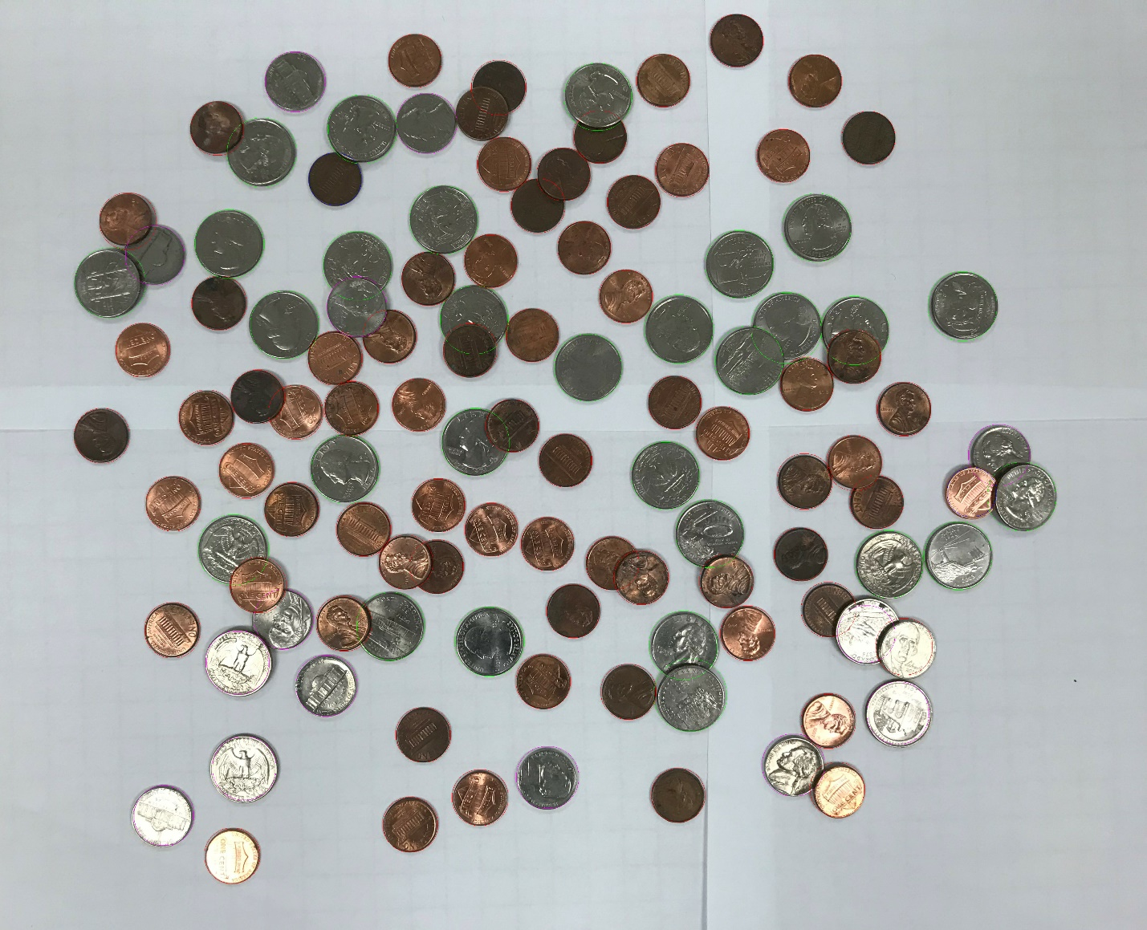

Results:

70 pennies

14 nickels

2 dimes

29 quarters

0 silver dollars

For a grand total of $8.85!

1. For the hard image

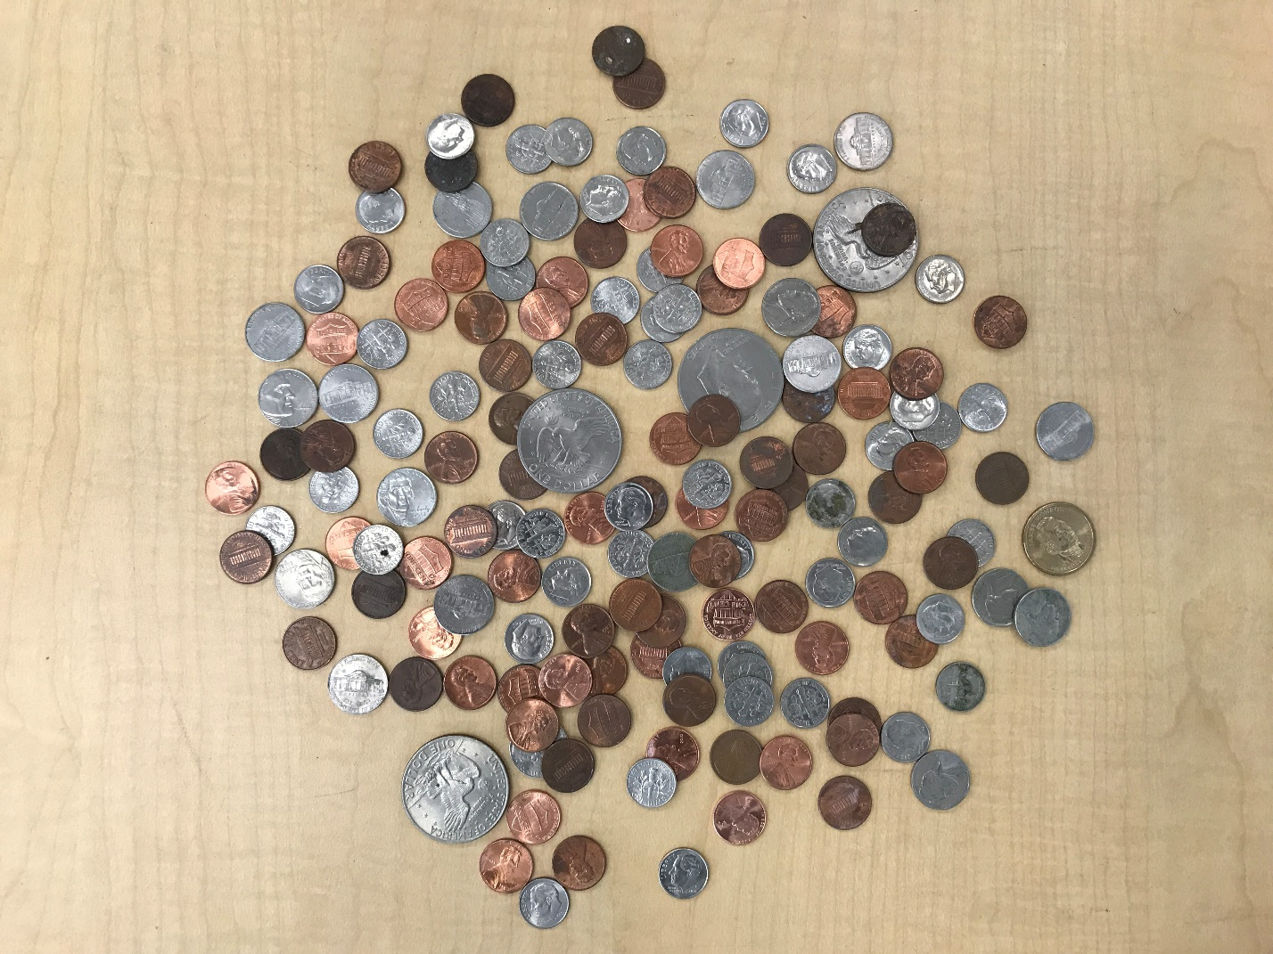

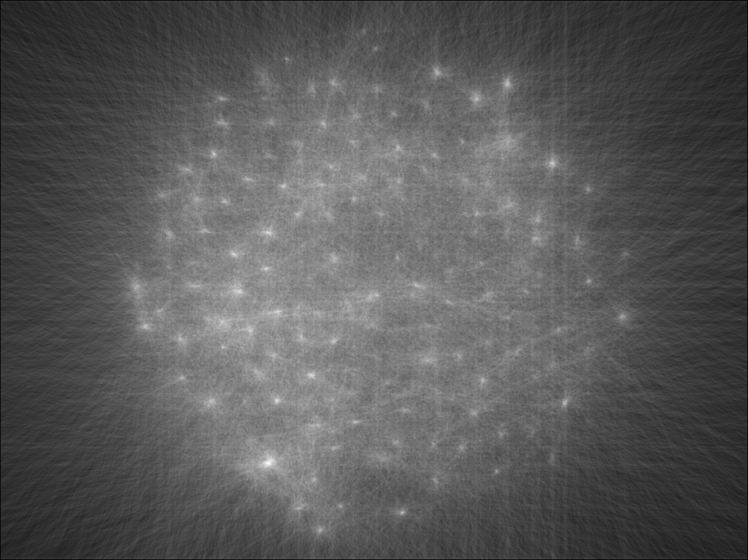

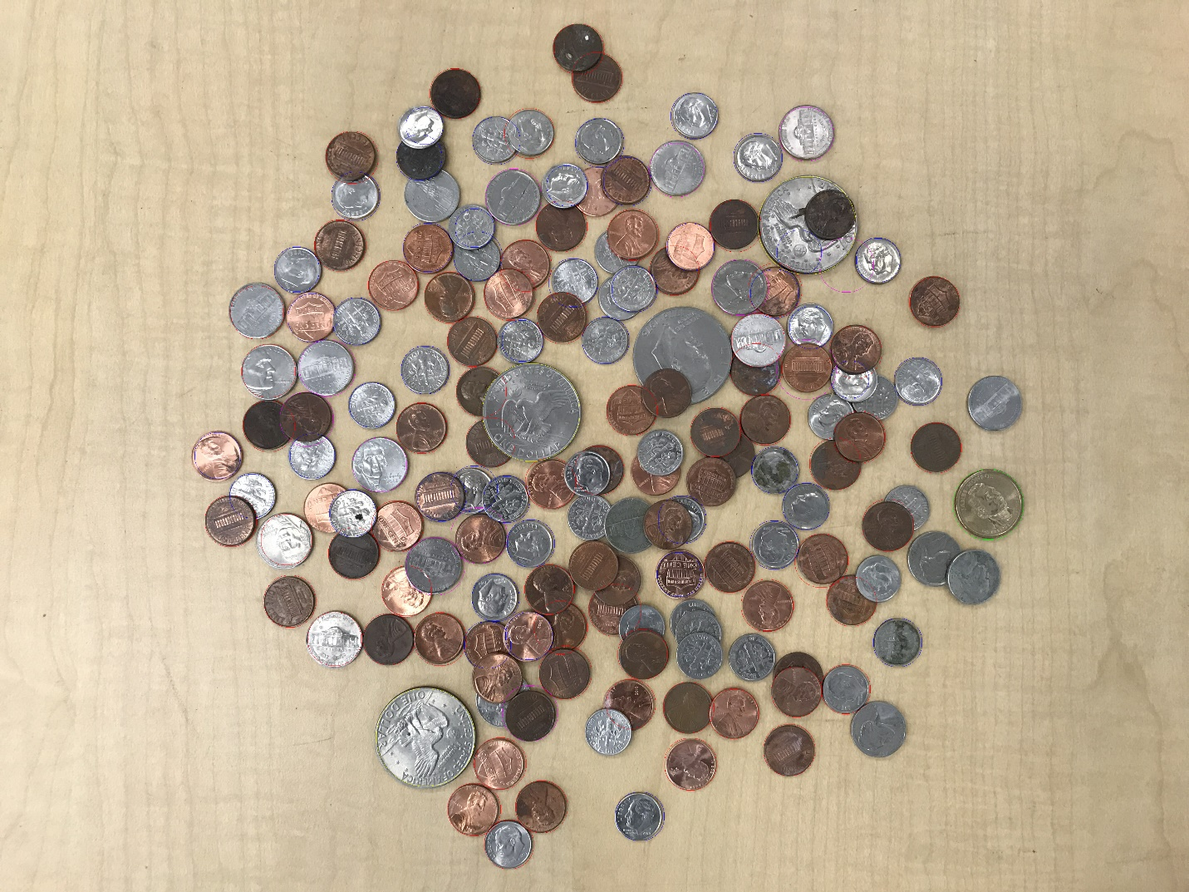

Result:

65 pennies

12 nickels

46 dimes

1 quarters

3 silver dollars

For a grand total of $9.10!